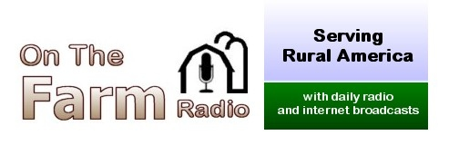

148 Liberty School Rd., Mount Sidney, VA 24467 (540) 424-4445
e-mail: jeff@onthefarmradio.com

AFFILIATE AGREEMENT

Call Letters:_____________________ AM FM Format:________________________

Business phone:_______________________ e-mail:______________________________

Web site address:______________________________________

GM name: _____________________________ PD name: __________________________________

Street address: _________________________________ City, State, ZIP: _________________________________

Mailing address:

Address: __________________________________________________

City, State, ZIP: _________________________________________________

Days and time of day program will air: ______________________________________________________

Programs will debut on (date):___________________________________________

Affiliation Agreement

On behalf of my station, I agree to air On the Farm Radio on the days and times specified above. I understand that I may change the broadcast days and/or times at my own discretion and that either party may cancel this affiliation agreement with 30 days notice.

Each program contains network commercials. I understand that I may insert local commercials within the breaks as appropriate, but that all network commercials must air in their entirety.

If requested, I agree to provide a quarterly affidavit verifying that the program and its network commercials were broadcast as planned on my station. If a copy of my log is requested, I agree to provide it in a timely manner.

Agreed by my signature: Date:________________________

__________________________________ ________________________________

Print name here:________________________ Title

